**BSCS FINAL PROJECT PROPOSAL**

TruSec (Trucking Surveillance System)

*Term of Registration: Fall 2023*



Presented by:

|  |  |
| --- | --- |
| **Registration No:** | **Name:** |
| L1F01BSCS0139 | Ahmed Naeem |
| L1F01BSCS0140 | Ahsan Jalil |
| L1F01BSCS0582 | Najam Irfan |

|  |
| --- |
| Faculty of Information Technology |

University of Central Punjab

**Project Title**

Trucking Surveillance System with Low Network Bandwidth support.

**Project Advisor**

Syed Nisar Ali

**Particulars of the students:**

|  |  |  |  |  |
| --- | --- | --- | --- | --- |
| **S.No** | **Registration#**  eg.**L1F00BSCS0101** | **Name in Full**  Use Block Letters | **CGPA** | **Signatures** |
| 1 | L1F19BSCS0139 | AHMED NAEEM | 2.34 |  |
| 2 | L1F19BSCS0140 | AHSAN JALIL | 1.98 |  |
| 3 | L1F19BSCS0582 | NAJAM IRFAN | 2.43 |  |

**Advisor’s Consent**

I Prof./Dr./Mr./Ms. Syed Nisar Ali am willing to guide these students in all phases of above-mentioned project as advisor. I have carefully seen the Title and description of the project and believe that it is of an appropriate difficulty level for the number of students named above.

|  |  |  |
| --- | --- | --- |
| **Note:**  Advisor can’t be changed without prior permission of the Manager Projects and the duration for completion of the Project is 2 regular semesters (approx.) from the date of Registration of Research Project. | Signatures and Date  |  | | --- | |  |   **Advisor** |

**EVALUATOR/REFEREE 1**

|  |  |  |  |  |  |
| --- | --- | --- | --- | --- | --- |
| I have carefully read the project proposal and feel that the proposed project is a useful one and of a sufficient difficulty level to justify 2 regular semesters workload for above mentioned students. I have made recommendations in the evaluation form to improve the scope and quality of the project. | | | | | |
|  | | | | Signatures and Date | |
|  |  |  |  |  |  |
|  | | | |  |

**EVALUATOR/REFEREE 2**

|  |  |  |  |  |  |
| --- | --- | --- | --- | --- | --- |
| I have carefully read the project proposal and feel that the proposed project is a useful one and of a sufficient difficulty level to justify 2 regular semesters workload for above mentioned students. I have made recommendations in the evaluation form to improve the scope and quality of the project. | | | | | |
|  | | | | Signatures and Date | |
|  |  |  |  |  |  |
|  | | | |  |

**Abstract / Executive Summary**

This project aims to develop a practical end-to-end solution for monitoring trucks carrying sensitive consignments over long distances in remote areas where secure surveillance systems are lacking. The solution integrates various technologies to ensure real-time visibility and enhanced security throughout the transportation process.

The system includes GPS tracking devices installed in each truck to monitor their precise location at all times. ESP32 device collect and transmit important vehicle data, such as speed, driver’s facial expression, and Geo Location enabling real-time monitoring of the truck's condition.

To ensure the proper handling of sensitive cargo, IoT sensors is deployed to monitor environmental factors such as temperature, humidity, and light exposure. These sensors provide continuous data transmission to a centralized control center, ensuring compliance with specific requirements.

In addition, strategically placed surveillance cameras inside the trucks capture the status of the consignments and allow live image feeds to be transmitted to the control center. This provides visual monitoring and enables immediate action in case of security breaches or irregularities.

To establish effective communication, a reliable network infrastructure is implemented, utilizing cellular networks and radio communication to transmit data from the trucks to the control center. This ensures uninterrupted monitoring even in remote areas with limited connectivity.

The control center serves as the centralized hub for data analysis, where incoming information is processed using machine learning algorithms to detect patterns, anomalies, or potential risks. Alarms and alerts are triggered when deviations from normal behaviors are identified, allowing for timely response and necessary interventions.

**Introduction and Background**

Trucks carrying sensitive consignments travel over long distances into remote areas, there is no secure surveillance system to monitor their status. This project aims to provide a practical end-to-end solution to overcome this problem. Moreover, during long driving hours, truck drivers may get drowsy or less attentive. To tackle this, we will embed a facial expressions detector that will cause an alarm whenever the driver will have a negative attitude.

We are developing a solution which uses an ESP32 microcontroller, paired with a Wi-Fi camera, GSM Module and Radio Waves Module. This ESP32 device will communicate with our Backend service hosted on AWS EC2 to post the image data and other relevant information to monitor the truck and truck driver.

The ESP32 device will periodically take snapshots using the Wi-Fi cameras. These Wi-Fi cameras will be connected locally with the microcontroller. Then the ESP32 MCU will send these snapshots over to our REST API. The embedded microcontroller will use the GSM Module (SIM Module), to transmit data primarily. As backup the device will use Radio Waves to transmit data. However, the snapshots transmitted using Radio Waves will have low image quality. These snapshots will also be used by our backend service to detect the facial expressions of the driver. These results will then be showed on the Angular dashboard.

**Statement of the Problem**

The main focus of TruSec will be to secure the trucks carrying sensitive consignments by allowing them to communicate effectively even over the low-bandwidth network. The current solutions in the market are costly because they are using satellite communication which is an expensive approach. Our aim is just to demonstrate the effective communication between the truck and the control center over low network bandwidth, and this will be our primary goal.

**Objective(s) / Aim(s) / Target(s)**

The project aims to provide a practical end-to-end solution for monitoring trucks carrying sensitive consignments in remote areas. By integrating GPS tracking, IoT sensors, surveillance cameras, communication networks, and data analytics, this solution offers real-time visibility, enhanced security, and efficient monitoring capabilities.

The implementation of such a comprehensive system enables continuous monitoring of the truck's location, vehicle condition, and cargo environment. The centralized control center, equipped with a monitoring dashboard and data analytics tools, empowers operators to detect anomalies, security threats, or deviations from normal behavior.

By leveraging technologies like networks, cloud platforms and IoT, the solution addresses the unique challenges presented by remote areas. It overcomes the limitations of existing surveillance systems and provides an efficient, reliable, and secure framework for monitoring trucks and their sensitive consignments.

**Completeness Criteria**

|  |  |  |
| --- | --- | --- |
| **S.No.** | **Criteria** | **Weightage %** |
| 1 | Web Dashboard | 20 |
| 2 | Backend API | 20 |
| 3 | Receiver and Transmitter MCU with IoT Sensors | 60 |

**Challenges**

* Implementation of Radio Transmitter and Receiver MCU to demonstrate low-bandwidth communication.
* To make our system fault tolerant we will embed GSM module to get maximum uptime.
* Training AI model and dataset acquisition to detect driver’s behavior.
* Implementation of web sockets for real time updates on admin dashboard.

**Knowledge Areas Required**

This project will require knowledge of electronics and microcontroller programming. Along with the expertise of web application development, WebSockets and API development. The AI and machine learning concepts will also help us to successfully complete the implementations.

**Learning Outcomes**

This project will help us understand the fundamentals of RF and GSM communication. Also, the hands-on implementation of AI model to detect the user expressions will allow us to become familiar with machine learning. This project also has a web development part which allow the students to comprehend basic fundamentals of web programming like WebSockets, Rest API etc.

**Nature of the End Product / Research Outcomes**

The end product will be a pair of MCUs one will be deployed on the truck which will work as a transmitter to send data, and the other one will be deployed in the control center which will work as a receiver to receive data from truck and upload it to the server. Along with the hardware we will have the admin dashboard where user can monitor the real-time updates from the truck.

**Related Work / Literature Survey / Literature Review**

A company known as GPSInsight provides a vehicle surveillance system that is overpriced. We distinguish at this point that GPSInsight is only being used in areas with high network bandwidth. Despite the fact our system uses a hybrid system with a combination of GSM Module and Radio Module to transmit data. This results in a practical and low-cost solution.

**Deliverables / Work Breakdown Structure**

**Project Plan / Project Schedule / Project Timetable / Project Calendar**



**Resources Required**

Following are the resources required to complete this project:

1. Visual Studio 2022
2. Aurdino IDE
3. EasyEDA
4. ESP32
5. WIFI Module
6. RF Module
7. GSM Module
8. Camera Module
9. PyCharm

**Miscellaneous**

Not applicable.

**Sketch of Proposed Solution (For Research-based and Hardware-Oriented Projects Only)**

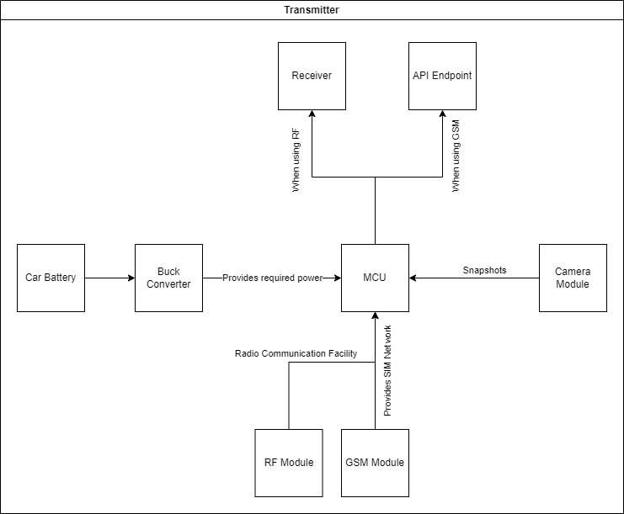

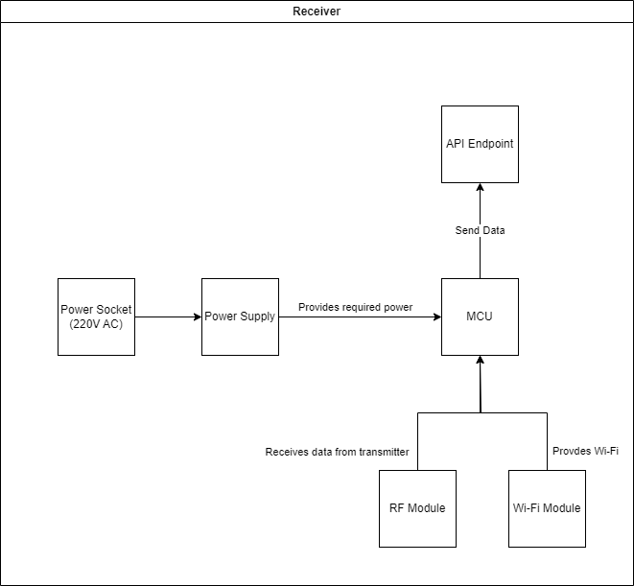

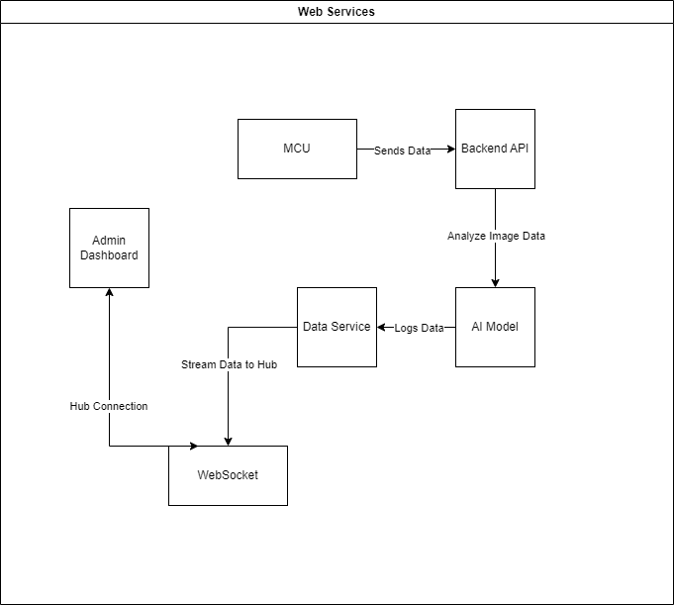

**References/Bibliography**

[1] “FER-2013 Facial Expressions Dataset.” <https://www.kaggle.com/datasets/msambare/fer2013>

[2] “TensorFlow lite support for microcontrollers.” <https://blog.tensorflow.org/2020/08/announcing-tensorflow-lite-micro-esp32.html>

[3] “ESP32 Wireless Communication Protocols.” <https://linuxhint.com/esp32-wireless-communication-protocols/>